**Data Science**

**Hourly 3**

**Customer Retention**

We all know that customers come and go. A good measurement is Customer Retention. We can count customers in a particular month and divide by the customers at the start.

I have applied cohort analysis which gives us a good food for thought. **Cohort Analysis** is one of the most powerful and demanded techniques available to marketers for assessing long-term trends in customer retention and calculating life-time value. I have made my own dataset for different groups for customers. There are Cohort01, Cohort02, etc. – cohort’s name due to customer signup date or first purchase date and M1, M2, etc. period of cohort’s life-time (first month, second month, etc.):

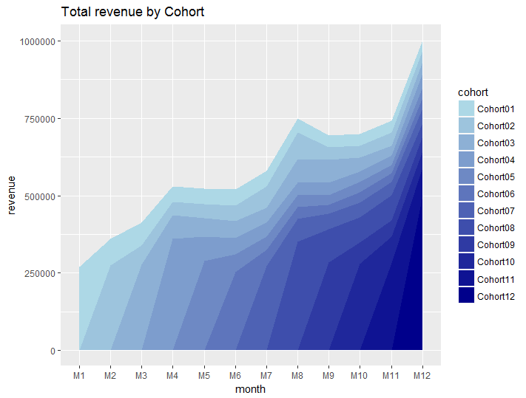

You can see that monthly revenue is highly dependent on new customers who do their first purchases. But during the time company accumulates several layers of incomes from existing (loyal) customers and reduced dependence

When we spend more money for attracting new customers then they bring us by the first but, usually, by the next purchases, we appeal to customer’s life-time value (CLV). We expect that customers will spend with us for years and it means we expect to earn some profit finally. In this case, retention is vital parameter. I have applied a formula to find retention ratio

**Retention ratio = # clients in particular month / # clients in 1st month of life-time**

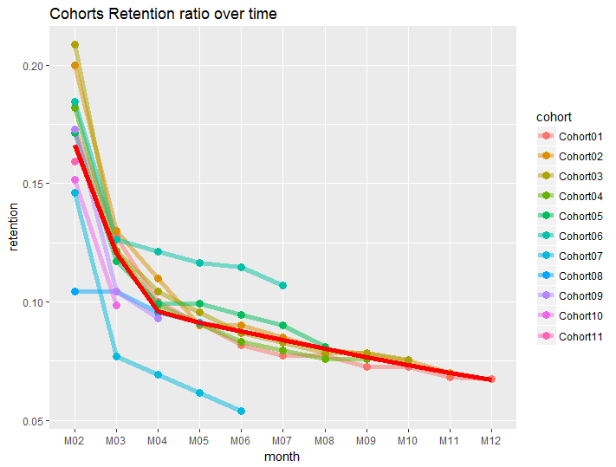

I’ve removed the first (M01) month from charts because it is always equal 1.0 (100%). The red line on the plot is the average ratio. It is easy to identify cohorts which are above and below. So, the first thought that I have is to compare them and find reasons of such difference.

This chart analyzing how many customers stick around for the second month

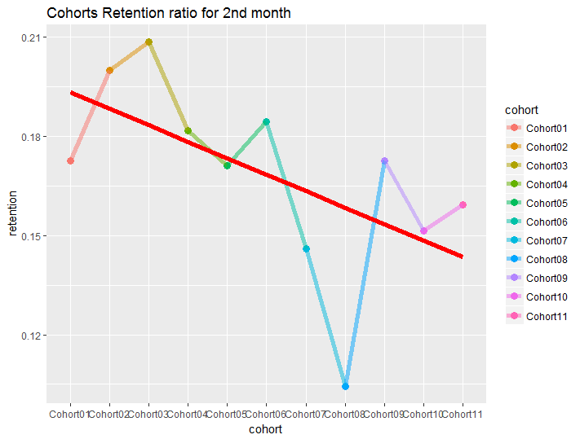

Our retention ratio decreased from 1.0 (100%) in the first month to 0.1-0.21 (10-21%) in the second month, this is the biggest drop in our example. That is why it is important to see how our dynamic changes (and its trend) from one cohort to another for the second month only.

**References**

http://analyzecore.com/2014/07/03/cohort-analysis-in-r-retention-charts/